Objectives
- To understand and implement the concept of facilities in GPSS by simulating a barbershop scenario.
- To model real-life situations using discrete event simulation techniques.
- To apply statistical randomness (arrival and service time variations) in simulations.
- To simulate the random walk (drunkard's walk) problem and understand probabilistic movement in one or two dimensions using any programming language.
- To gain practical experience in using simulation as a tool for analyzing real-world systems.

Q.no.1. Customers arrive at Joey’s Barber Shop once every 15±3 minutes and it takes Joey 18±2 minutes to cut the hair of a customer. Write a GPSS program to simulate a barbershop using the concept of facility and run the simulation for 9 hours.
Source Code
GENERATE 15,3
QUEUE BARBERQ
SEIZE JOEY
DEPART BARBERQ
ADVANCE 18,2
RELEASE JOEY
TERMINATE 1
JOEY STORAGE 1
START 54

Output
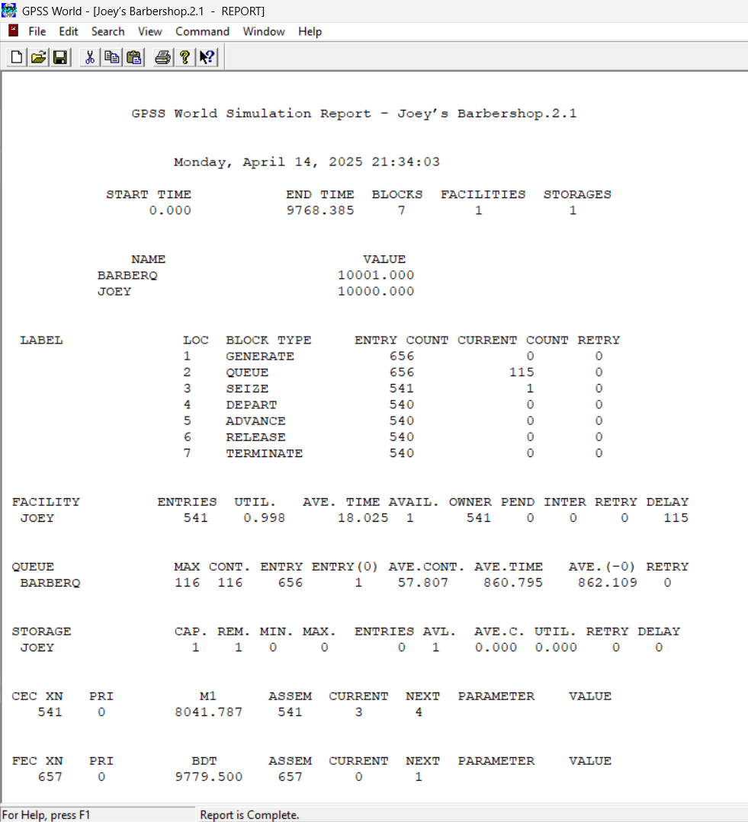

Q.no.2. Simulate a random walk problem or a drunkard problem in any programming language.
Source Code
#include <stdio.h>
#include <stdlib.h>
#include <time.h>

#define STEPS 100

int main() {
int x = 0, y = 0;
srand(time(0));

printf("Random Walk (2D) Starting from (0,0):\n");
printf("Step 0: (%d, %d)\n", x, y);

for (int i = 1; i <= STEPS; i++) {
int direction = rand() % 4;

switch (direction) {
case 0: y++; break; // North
case 1: y--; break; // South
case 2: x++; break; // East
case 3: x--; break; // West
}

printf("Step %d: (%d, %d)\n", i, x, y);
}

printf("Final Position after %d steps: (%d, %d)\n", STEPS, x, y);
return 0;
}

.Output
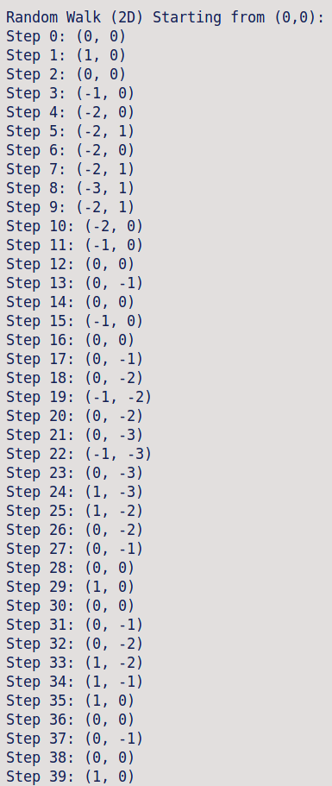
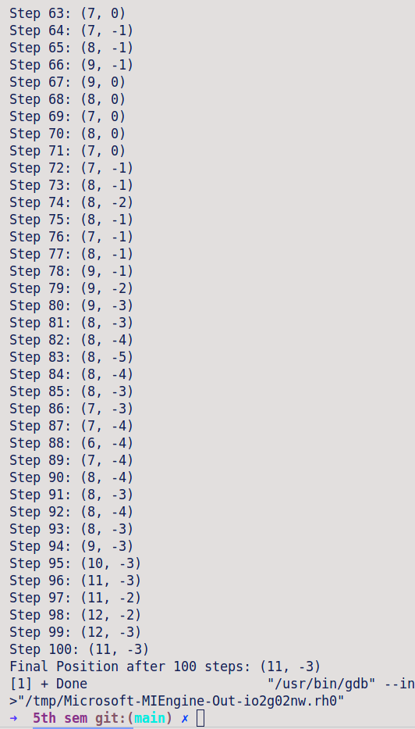

Conclusion
In this lab, we successfully simulated Joey’s Barbershop using GPSS by incorporating randomness in customer arrival and service times. The use of facilities in GPSS allowed us to model the queueing and servicing process effectively. Additionally, by simulating the random walk problem, we gained insights into stochastic processes and their behavior over time. These simulations highlight the power of modeling and randomness in understanding complex systems and contribute to building foundational skills in simulation and probabilistic modeling.

